A Unified IoT Framework for Behavior-Adaptive Appliance Control in Smart Residential Spaces

Mr. Prashant Pandey   
Computer Science and Engineering (IoT)  
NIET, Greater NoidaGreater Noida, India  
prashanthts684@gmail.com

Mr. Praveen Pandey  
Computer Science and Engineering (IoT)  
NIET, Greater NoidaGreater Noida, India  
pp414717@gmail.comMr. Rajnish Kumar Rai  
Computer Science and Engineering (IoT)  
NIET, Greater NoidaGreater Noida, India  
rajnishkumarrai8968@gmail.com

### Ms. Smrita Chaubey Computer Science and Engineering (IoT) NIET, Greater Noida Greater Noida, India smrita.chaubey@niet.co.inMr. Shivam Kumar Mishra Computer Science and Engineering (IoT) NIET, Greater Noida Greater Noida, India shivammishra2487768@gmail.com

*Abstract*— The paper focuses on the architectural development of an IoT Framework that unifies the way you control various smart appliances. It takes a nodal approach to reduce the need of redundant sensors across various appliances. The benefits of this approach is that, it provides for a more inclusive automation adapting to the behavior of the user.

Keywords— IoT, Smart Home, Centralized Control, Energy Efficiency, Adaptive Systems, User Behavior Learning

# Introduction

A world in which all of our technological devices are completely connected, is frequently what comes to mind when we envision the future of human life. An environment where devices operate without human intervention, learning and adapting to our routines. The smart home technologies of today, however, fall well short of this goal. Although we do have sophisticated gadgets, but they primarily function alone. The missing link is integration — for instance, a smart refrigerator exists, but it can’t communicate with the air conditioner or adapt to the user's behavior across systems.

Several key issues need to be tackled, such as sensor redundancy, energy waste, and poor coordination. For example, a smart air conditioner and a smart refrigerator both contain similar sensors to monitor the room temperature and adjust their functionality accordingly. This leads to redundant temperature sensors across devices. Moreover, the same physical parameter being measured by multiple devices results in increased energy consumption.

This is the motivation to device a solution that accounts to a centralized sensing and decision-making framework[1].

# Related Works

## Google Nest Ecosystem

It is a collection of various products provided by google to make homes more connected, efficient and easy to control. They are controlled with Google Home app or using Google Assistant. The Nest ecosystem includes Nest Thermostat, Nest Cameras, etc.

But what this ecosystem lacks are a holistic view across rooms. It has a more appliance-centric-intelligence and each device has its own set of sensors leading to sensor redundancy.

## Samsung Smart Things

Similar to Google’s Nest Ecosystem, Samsung’s SmartThings is also a platform for smart homes but unlike the Nest, it allows the central hub to connect smart devices of various brands. The automations are based on simple rules (like- “If motion is detected, turn on the lights”).

The automations are basic and rules based and not dynamic and adaptive to external factors like weather. It also requires the appliances to be smart on their own adding the redundant sensor cost. Also, there is no real time learning or optimization across the whole room.

# System Architecture

The proposed centralized IoT-based smart home system is designed to optimize energy consumption, enhance user comfort, and reduce redundancy in sensor deployment[2]. The architecture integrates sensor nodes at room level and also have a central control unit which facilitates intelligent decision-making based on both local and global environmental data acquired.[3]

## Room Sensor Nodes (RSN)

Each room is equipped with an RSN, a compact module containing a suite of sensors to monitor environmental parameters such as temperature, humidity, light intensity, motion, and air quality[4]. These nodes collect real-time data and transmit it to the Central Control Unit (CCU) for analysis[5]. Also, they have a local processing unit embedded within, so as to take some instantaneous decisions like switching on the lights when motion is detected[6], [7].

## Central Control Unit (CCU)

The CCU acts as the system's brain, accumulating data from all RSNs and external sources like weather APIs. It then processes this data to determine the most suitable appliance settings. It learns user’s habits over time to predict preferences and automate the decisions. The CCU decides the most reasonable actions like- turning on/off lights, adjusting fans, ACs, air purifiers etc.

## Actuators

Based on CCU directives, actuators control appliances (e.g., lights, fans, HVAC systems) within each room, adjusting their operation to maintain desired environmental conditions and user comfort[8].

## 

1. Architectural diagram of the Control system

## Communication Protocols

For the suggested system to work, there must be efficient communication between the Central Control Unit (CCU), appliance controllers, and Room Sensor Nodes (RSNs)[9], [10]. Real-time data transfer with low latency and power consumption is supported by the system's scalable, effective, and lightweight communication protocols[11].

1. *MQTT (Message Queuing Telemetry Transport):* The system makes use of the MQTT protocol as its primary communication protocol.[12] This publish-subscribe-based messaging protocol is suitable for low-bandwidth, high-latency, or unreliable networks which are ideal for IoT systems.[13] Devices (RSNs) publish sensor data to specific topics (e.g., room1/temp), while the CCU subscribes to these topics to receive updates in real-time. MQTT has a small code footprint and low overhead, making it suitable for microcontroller-based devices with limited processing power and memory. Environmental data, such as temperature, humidity, and mobility, are published by RSNs. CCU publishes control decisions (e.g., room1/fan/control) and subscribes to all RSNs. In order to receive commands, actuator devices subscribe to relevant control topics.
2. *HTTP/Rest (For external API access):* To incorporate external environmental context into its decision-making, the Central Control Unit (CCU) utilizes HTTP-based RESTful APIs to access third-party services. We pull in data from these APIs on a regular basis—things like outside temperature, humidity, UV levels, and weather alerts (think rain or storm warnings). By combining that info with readings from our Room Sensor Nodes, the system can make smarter choices. For instance, if it’s already cool outside, we dial back the indoor cooling to save energy.
3. *Wi-Fi as Physical Layer:* The system employs Wi-Fi (IEEE 802.11) as the primary physical communication layer due to its widespread availability in residential settings and higher data throughput compared to protocols like ZigBee or Bluetooth[14]. Wi-Fi’s ease of integration with existing home routers makes it a practical choice for real-world deployment. However, in scenarios where power consumption is a critical factor—such as with battery-powered sensor nodes—alternative communication technologies like ZigBee or LoRa may be considered in future iterations to enhance energy efficiency and network longevity.[15]

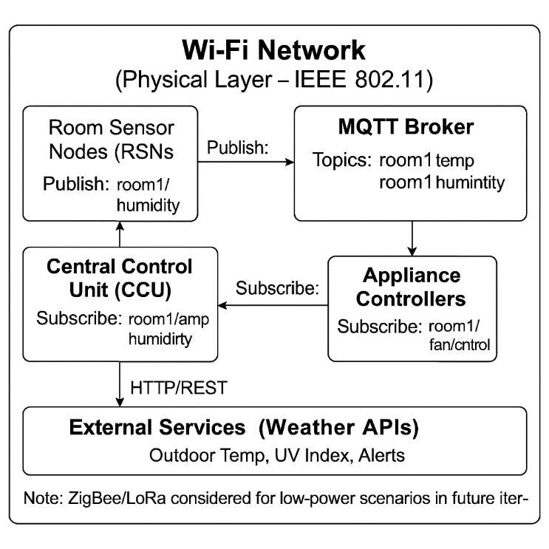

1. Illustration of the use of communication protocols in the system

# Mathematical Modeling

## To ensure the proposed smart home system operates intelligently and efficiently, several mathematical models are employed. These models guide decision-making by quantifying environmental conditions, estimating user comfort, predicting behavior, and optimizing energy usage.

## Sensor Data Aggregation

Sensor nodes in each room collect multiple environmental parameters. To process these inputs effectively, we define a normalized aggregation function:[16]

$S_{r}\left(t\right)= \sum_{i=1}^{n}{w_{i}}∙ \frac{x_{i}\left(t\right) - x_{i}^{min}}{x_{i}^{max}- x_{i}^{min}}$



Where,

* $S_{r}\left(t\right)$: Aggregated sensor score for room ‘r’ at time ‘t’.
* $x_{i}\left(t\right)$: Value of sensor ‘i’ at time ‘t’.
* $w_{i}$ ​: Weight assigned to sensor ‘i’ (based on importance).
* $x_{i}^{max}, x_{i}^{min}$*​:* Normalization bounds for sensor ‘i’.
* *n*: Number of sensors in the node[17]

This normalization ensures that sensor values of different scales (e.g., temperature in °C, CO₂ in ppm) contribute proportionally to the system's decisions.

## Comfort Score Formula

## The comfort score quantifies how suitable the current room environment is for occupancy based on user preferences and environmental thresholds[18], [19], [20]. It is defined as:

$C_{r}\left(t\right)= α∙T_{s}+ β∙H_{s}+ γ∙A_{s}+ δ∙L_{s}+ ε∙O_{s}$



Where,

* $C_{r}\left(t\right)$: Comfort score for room ‘r’ at time ‘t’.
* $T_{s}, H_{s}{, A}_{s}, L_{s}, O_{s}$ ​: Normalized scores for temperature, humidity, air quality, light, and occupancy respectively.
* $α, β, γ, δ, ε$: Tunable coefficients reflecting the relative importance of each parameter.

A higher $C_{r}\left(t\right)$ indicates a more comfortable environment. Thresholds can be defined to trigger control actions (e.g., turning on ventilation if air quality drops).

# Proposed Methodology

To effectively realize the previously discussed system architecture, a structured methodology is essential. This will not only help achieve the intended outcomes but also clarify how information flows throughout the system and the sequence in which tasks are executed and controlled.

## Data Acquisition

## Every room is fitted with a virtual sensor group that records real-time environmental details. These sensors measure variables like temperature, humidity, brightness, air quality (AQI), and occupancy. For testing purposes, data is produced over a 24-hour period, refreshed hourly, enabling the system to replicate daily changes in the environment and occupant behavior[21].

## Data Aggregation

Sensor inputs are merged into a single figure that reflects the room’s overall state. This figure is derived by averaging adjusted values of temperature, humidity, air quality, and brightness—specifically, temperature, humidity, (100 minus AQI), and (brightness divided by 10). This combined metric lays the groundwork for assessing comfort levels and directing appliance actions.

## Comfort level assessment

The system computes a comfort level using the compiled data to evaluate how near the room’s conditions are to the user’s ideal preferences. Each element—temperature, humidity, brightness, and air quality—receives a sub-score from 0 to 1, based on its difference from the desired setting. The total comfort level is the average of these sub-scores. Should this level dip below a set point, such as 0.75, the system adjusts appliances to enhance comfort.

## Habit recognition and behaviour prediction

Over time, the system quietly keeps tabs on each room—logging when and how you use appliances by the hour. It spots those regular habits and starts predicting what you’ll want next. So if you always switch on the fan at 3 p.m., it’ll learn that pattern and take care of it for you automatically.

## Centralized management

Using both your comfort preferences and the habits it’s learned, the central control unit (CCU) decides which devices to turn on or off. It keeps all the room sensors in sync, while also factoring in outside conditions—like temperature or weather alerts pulled via live or simulated feeds. And if circumstances change—say you’ve stepped out—the CCU can override individual room settings, shutting everything down until you return.

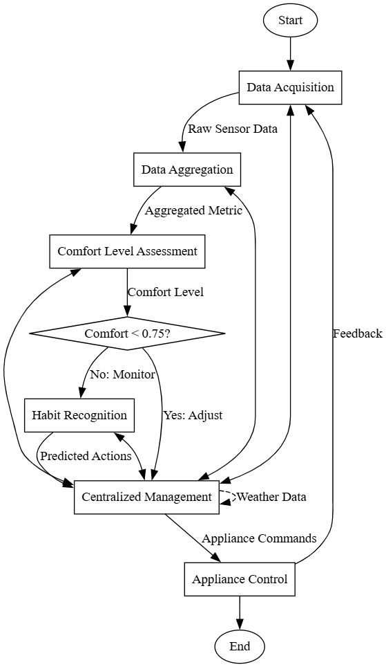

1. Flow chart of the proposed methodology

# Experimentation

For this system we planned a simulation experiment that puts our centralized smart home system to the test. Using Python, we created a virtual setup with three rooms, each decked out with sensors that mimic real-world conditions over a full day. The idea is to see how well the system adapts to changes in the environment and learns from user habits, all while keeping an eye on energy use and comfort levels.

## Simulation Environment

## For the simulation, we used Python on Google Colab to create a virtual environment with three rooms. Each room has sensors that measure things like: Temperature, Humidity, Light levels, Air quality, Whether someone’s in the room. These sensors spit out data every hour, and we made sure the readings make sense for a typical day, even though they’re randomly generated within certain limits.

## Data processing and Control Logic

The system takes all the sensor data and crunches it into a single comfort score for each room. If this score drops below a certain level—say, 0.75—the system kicks into action. It decides which appliances to turn on, like the fan, AC, or lights, based on what’s needed and what it knows about the user’s habits. But if no one’s in the room, everything stays off to save energy. There’s also a smart module that learns from past usage, so over time, the system gets better at predicting what the user wants.

Overall, this simulation helps us see how well our smart home system can juggle comfort and energy efficiency in a realistic setting. It’s all about making sure the system can adapt and learn, just like a real smart home should.

# Results and discussions

Although the proposed centralized smart home control architecture has not yet been physically implemented, a thorough conceptual analysis provides insight into its expected performance, strengths, and design trade-offs. Table I consists of some of the data generated over a span of 24 hour.

1. Comfort Score and Appliance Control

| ***Hour*** | Room | Temp | Presence | Comfort Score | Fan | AC | E (kWh) |
| --- | --- | --- | --- | --- | --- | --- | --- |
| 0 | Room1 | 20 | 1 | 0.58 | OFF | OFF | 20 |
| 0 | Room2 | 28 | 1 | 0.62 | OFF | ON | 1520 |
| 0 | Room3 | 31 | 0 | 0.54 | OFF | OFF | 0 |
| 1 | Room1 | 29 | 0 | 0.3 | OFF | OFF | 0 |
| 1 | Room2 | 24 | 1 | 0.81 | OFF | OFF | 20 |
| 1 | Room3 | 24 | 0 | 0.88 | OFF | OFF | 0 |
| 2 | Room1 | 24 | 0 | 0.78 | OFF | OFF | 0 |

## Visual Representations

### Simulated outputs using generated data over a 24-hour cycle help demonstrate how the system operates under varied environmental and occupancy conditions. Two key visualizations were produced: a heatmap of user appliance interaction and a line graph of energy usage per room.:

### User Habit Learning (Figure 4)

### The heatmap shows familiar routines—like lights coming on at dawn or the AC kicking in as evening rolls around—demonstrating how the system picks up on your habits and starts handling them automatically based on who’s home and what the conditions are.

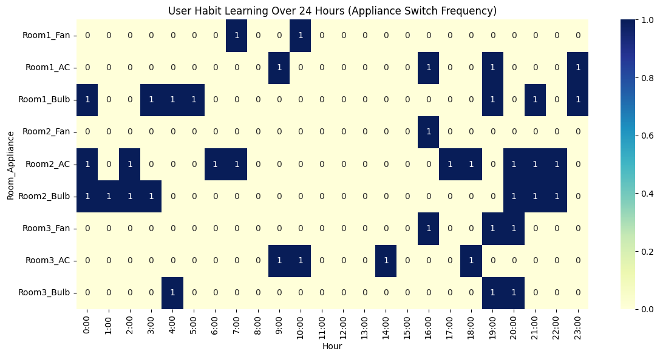

1. User Habit Learning Heatmap

### Energy Usage Trends (Figure 5)

The energy consumption graph illustrates that appliance usage peaks during active occupancy periods and remains minimal otherwise. This behavior is the result of intelligent appliance control based on comfort scores and habit prediction, which ensures energy is only consumed when necessary.

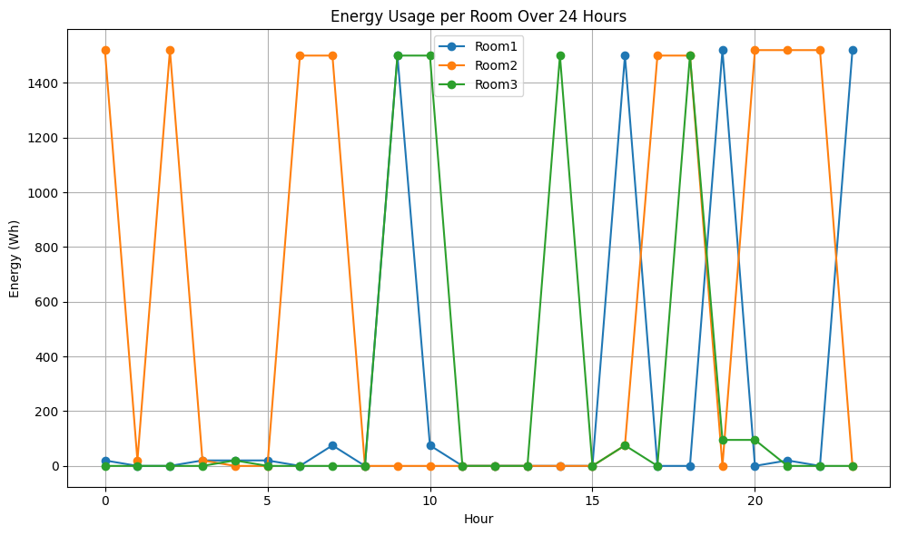

1. Energy Consumption Over 24 Hours

## Strengths of the proposed system

### Centralized Intelligence: By funneling all sensor data into one smart hub, we cut down on duplicate hardware and make decision-making much simpler.

### Personal Touch: The system gets to know your daily routines and quietly adjusts settings to keep you comfortable—no constant button-pressing required.

### Built to Grow: Each room’s sensor node works independently, so you can easily expand from a cozy apartment to a sprawling multi-floor home.

## Potential Limitations

### Network Reliance: Since the nodes chat over Wi-Fi, you might see occasional hiccups or delays if the connection goes spotty.

### Learning Curve: It takes a brief “getting to know you” phase before the automation really hits its stride, so things may feel a little off at first.

### Security Needs: With all data flowing through a central point—and some features talking to outside services—it’s essential to lock everything down with strong access controls and encryption[22].

# Conclusion

In this study, we introduce a smart home design that brings all the “brains” into one central hub while still using flexible, plug-and-play sensor modules in each room. By having room-level sensors talk to a single control unit, we cut down on extra hardware and streamline how everything works—improving both your comfort and your energy savings.

Our main achievements are threefold: a lightweight network of sensor nodes, a habit-learning algorithm that predicts what you’ll do next, and an energy-smart control system that balances efficiency with your personal comfort. Looking ahead, we see exciting possibilities like adding facial or voice recognition, tapping into more powerful AI for deeper personalization, rolling this out in offices or hotels, and even blending edge-and-cloud processing to keep things fast and efficient in real time.

##### Acknowledgment

We would like to sincerely thank Miss Smrita Chaubey, Faculty in the Department of Computer Science and Engineering (IoT), for her unwavering guidance and support throughout the development of this project. Her deep knowledge, thoughtful feedback, and constant encouragement played a key role in shaping both the system architecture and the overall concept. Her insights truly made a difference, and we’re grateful for her mentorship.

##### References

[1] M. Abu Alsheikh, D. T. Hoang, D. Niyato, H.-P. Tan, and S. Lin, “Markov Decision Processes With Applications in Wireless Sensor Networks: A Survey,” *IEEE Commun. Surv. Tutor.*, vol. 17, no. 3, pp. 1239–1267, 2015, doi: 10.1109/COMST.2015.2420686.

[2] J. Iqbal *et al.*, “A generic internet of things architecture for controlling electrical energy consumption in smart homes,” *Sustain. Cities Soc.*, vol. 43, pp. 443–450, Nov. 2018, doi: 10.1016/j.scs.2018.09.020.

[3] A. H. Kazmi, M. J. O’grady, D. T. Delaney, A. G. Ruzzelli, and G. M. P. O’hare, “A Review of Wireless-Sensor-Network-Enabled Building Energy Management Systems,” *ACM Trans. Sens. Netw.*, vol. 10, no. 4, pp. 1–43, Jun. 2014, doi: 10.1145/2532644.

[4] W.-Y. Chung and S.-J. Oh, “Remote monitoring system with wireless sensors module for room environment,” *Sens. Actuators B Chem.*, vol. 113, no. 1, pp. 64–70, Jan. 2006, doi: 10.1016/j.snb.2005.02.023.

[5] B. Nugraha, R. Nair, and K. Muhammad, “Smart Real Time Data Transfer Surveillance with Edge Computing and Centralized Remote Monitoring System,” in *Day 2 Tue, January 14, 2020*, Dhahran, Kingdom of Saudi Arabia: IPTC, Jan. 2020, p. D022S182R001. doi: 10.2523/IPTC-19588-MS.

[6] L. Lacassagne, A. Manzanera, J. Denoulet, and A. Mérigot, “High performance motion detection: some trends toward new embedded architectures for vision systems,” *J. Real-Time Image Process.*, vol. 4, no. 2, pp. 127–146, Jun. 2009, doi: 10.1007/s11554-008-0096-7.

[7] C. W. G. Clifford and M. R. Ibbotson, “Fundamental mechanisms of visual motion detection: models, cells and functions,” *Prog. Neurobiol.*, vol. 68, no. 6, pp. 409–437, Dec. 2002, doi: 10.1016/S0301-0082(02)00154-5.

[8] S. M. Zanoli and C. Pepe, “Thermal, Lighting and IAQ Control System for Energy Saving and Comfort Management,” *Processes*, vol. 11, no. 1, p. 222, Jan. 2023, doi: 10.3390/pr11010222.

[9] M. Li and H.-J. Lin, “Design and Implementation of Smart Home Control Systems Based on Wireless Sensor Networks and Power Line Communications,” *IEEE Trans. Ind. Electron.*, vol. 62, no. 7, pp. 4430–4442, Jul. 2015, doi: 10.1109/TIE.2014.2379586.

[10] C. Suh and Y.-B. Ko, “Design and implementation of intelligent home control systems based on active sensor networks,” *IEEE Trans. Consum. Electron.*, vol. 54, no. 3, pp. 1177–1184, Aug. 2008, doi: 10.1109/TCE.2008.4637604.

[11] Z. Ma, M. Xiao, Y. Xiao, Z. Pang, H. V. Poor, and B. Vucetic, “High-Reliability and Low-Latency Wireless Communication for Internet of Things: Challenges, Fundamentals, and Enabling Technologies,” *IEEE Internet Things J.*, vol. 6, no. 5, pp. 7946–7970, Oct. 2019, doi: 10.1109/JIOT.2019.2907245.

[12] J. Dizdarević, F. Carpio, A. Jukan, and X. Masip-Bruin, “A Survey of Communication Protocols for Internet of Things and Related Challenges of Fog and Cloud Computing Integration,” *ACM Comput. Surv.*, vol. 51, no. 6, pp. 1–29, Nov. 2019, doi: 10.1145/3292674.

[13] M. O. A. Enany, H. M. Harb, and G. Attiya, “A New Back-off Algorithm with Priority Scheduling for MQTT Protocol and IoT Protocols,” *Int. J. Adv. Comput. Sci. Appl.*, vol. 12, no. 11, 2021, doi: 10.14569/IJACSA.2021.0121140.

[14] J.-S. Lee, Y.-W. Su, and C.-C. Shen, “A Comparative Study of Wireless Protocols: Bluetooth, UWB, ZigBee, and Wi-Fi,” in *IECON 2007 - 33rd Annual Conference of the IEEE Industrial Electronics Society*, Taipei, Taiwan: IEEE, 2007, pp. 46–51. doi: 10.1109/IECON.2007.4460126.

[15] J. O. Ogbebor, A. L. Imoize, and A. A.-A. Atayero, “Energy Efficient Design Techniques in Next-Generation Wireless Communication Networks: Emerging Trends and Future Directions,” *Wirel. Commun. Mob. Comput.*, vol. 2020, pp. 1–19, Mar. 2020, doi: 10.1155/2020/7235362.

[16] K. Akkaya, M. Demirbas, and R. S. Aygun, “The impact of data aggregation on the performance of wireless sensor networks,” *Wirel. Commun. Mob. Comput.*, vol. 8, no. 2, pp. 171–193, Feb. 2008, doi: 10.1002/wcm.454.

[17] P. Viertel, M. Küper, J. Wiegmann, and M. König, “Determining room usage through a multi-sensor system and machine learning”.

[18] J. Kim, S. Schiavon, and G. Brager, “Personal comfort models – A new paradigm in thermal comfort for occupant-centric environmental control,” *Build. Environ.*, vol. 132, pp. 114–124, Mar. 2018, doi: 10.1016/j.buildenv.2018.01.023.

[19] A. M. Atzeri, F. Cappelletti, A. Tzempelikos, and A. Gasparella, “Comfort metrics for an integrated evaluation of buildings performance,” *Energy Build.*, vol. 127, pp. 411–424, Sep. 2016, doi: 10.1016/j.enbuild.2016.06.007.

[20] Y. Song, F. Mao, and Q. Liu, “Human Comfort in Indoor Environment: A Review on Assessment Criteria, Data Collection and Data Analysis Methods,” *IEEE Access*, vol. 7, pp. 119774–119786, 2019, doi: 10.1109/ACCESS.2019.2937320.

[21] K. T. Min, “WIRELESS SENSOR NETWORKS FOR EXPOSURE SCIENCE AND ENVIRONMENTAL MONITORING”.

[22] E. Meshkova *et al.*, “Designing a Self-Optimization System for Cognitive Wireless Home Networks,” *IEEE Trans. Cogn. Commun. Netw.*, vol. 3, no. 4, pp. 684–702, Dec. 2017, doi: 10.1109/TCCN.2017.2755010.